



A.P.S. Peiris -10026335

https://github.com/amalpeiris20

B.K.J. Dissanayaka -10026499

https://github.com/kadi99

D.S. Vitharana -10026562

https://github.com/dilunikasv

P.G.V.V.P. Gallage -10026693

https://github.com/Vijjaaa

J.A. Rathnayaka -10026829

https://github.com/jananiamandaaa

Lecturer: Mr. Chaminda Wijesinghe

**Table of Contents**

**1. Home Page**

**1.1 Sign In page**

**1.2 Sign Up Page**

**1.3 Book Category Page**

**1.4 Contact Us Page**

**1.5 PHP Part and Database**

**1.Home Page**

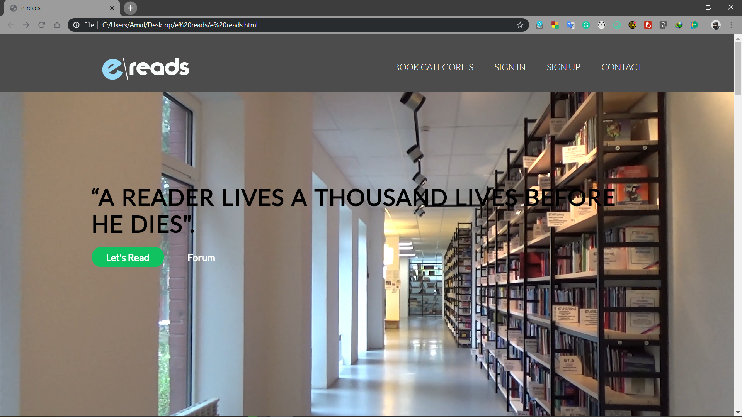



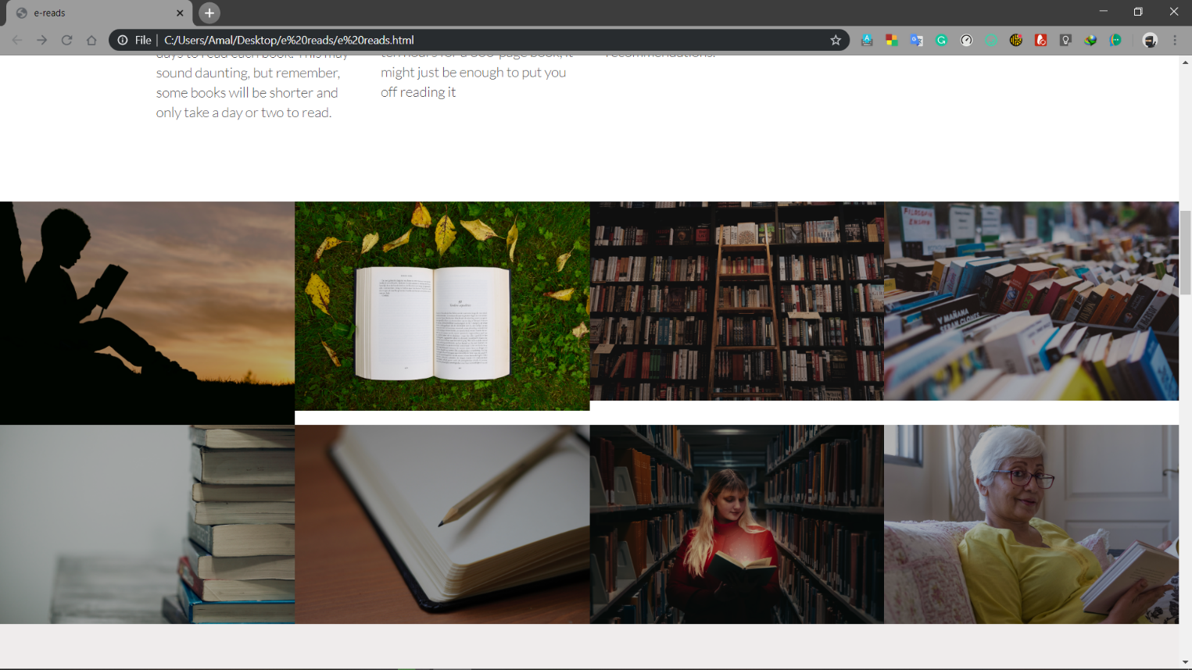

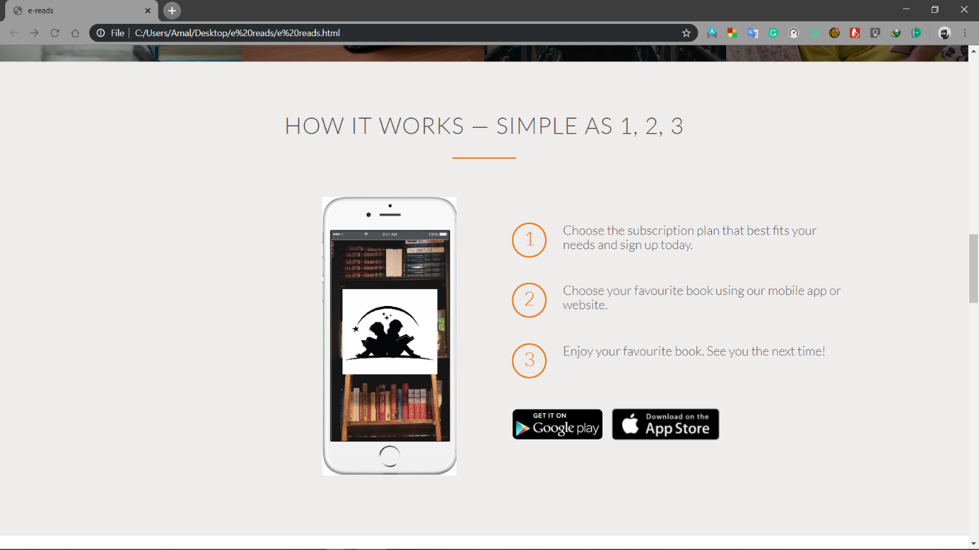

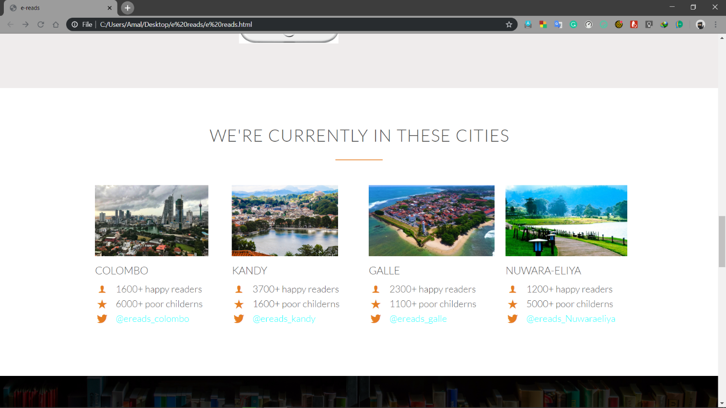

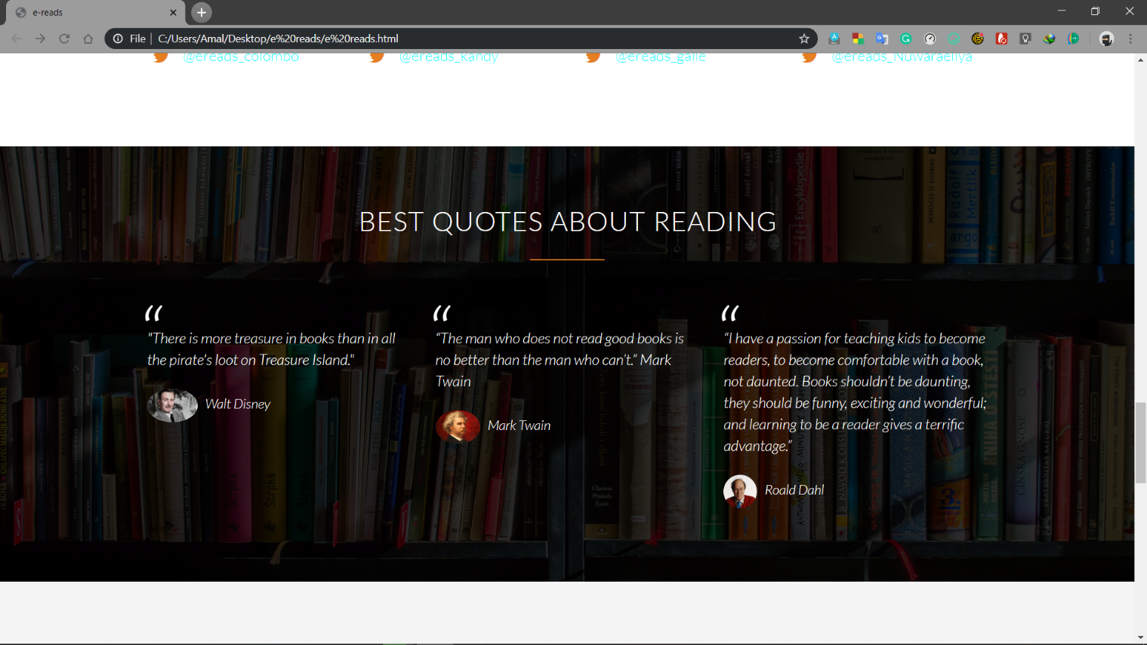

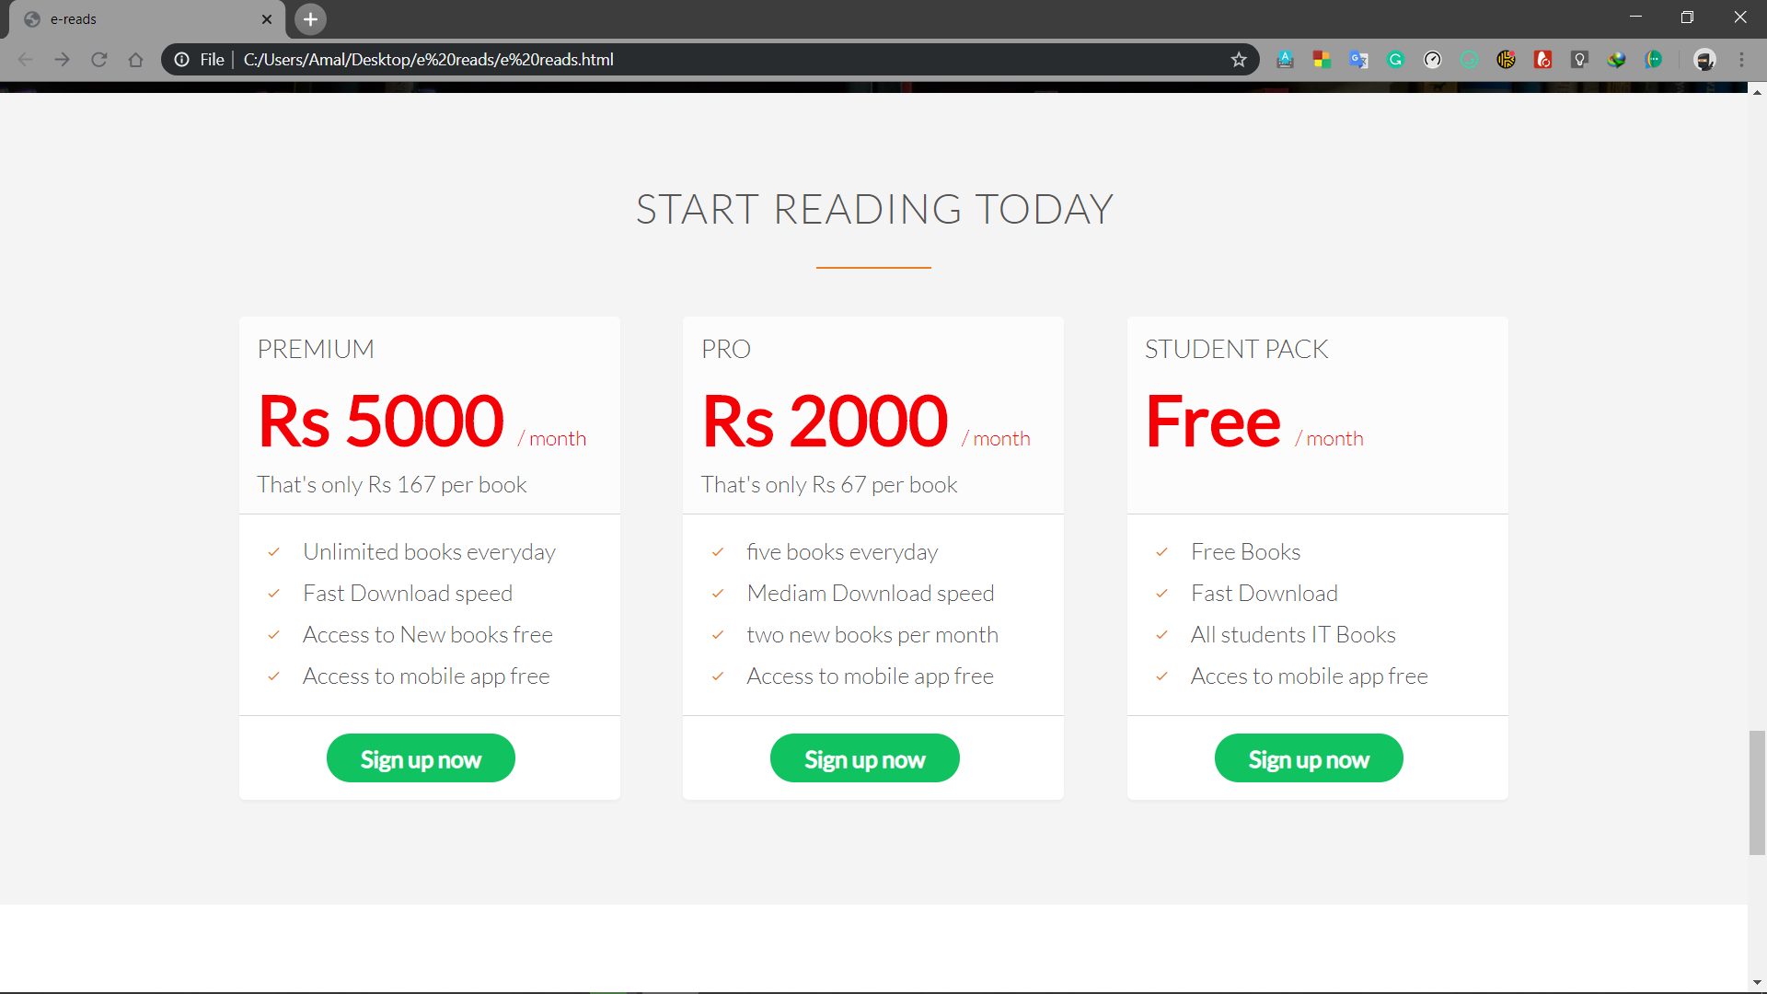

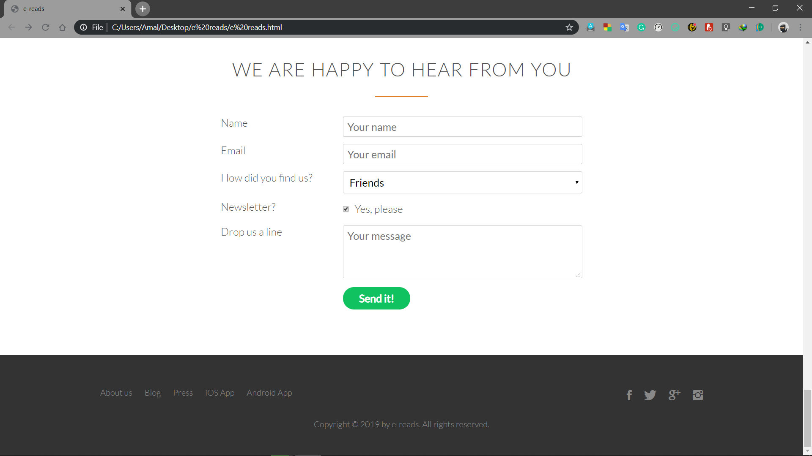

* 1. **Sign In page**

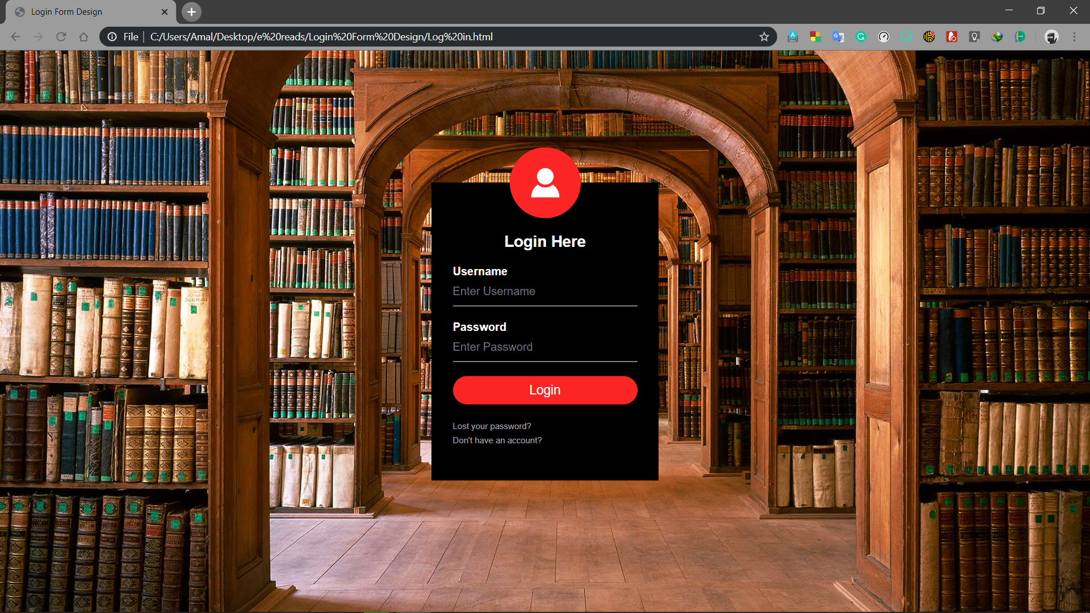

* 1. **Sign Up Page**

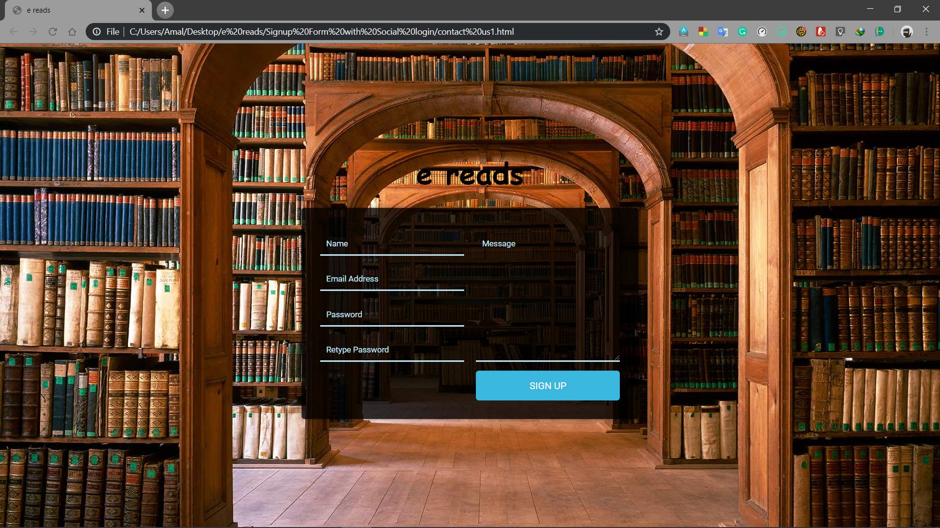

* 1. **Book Category Page**



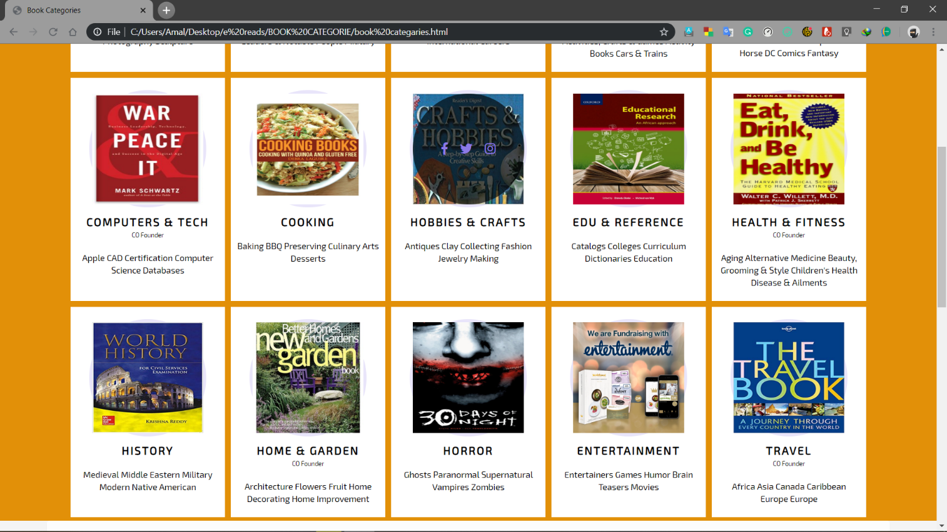

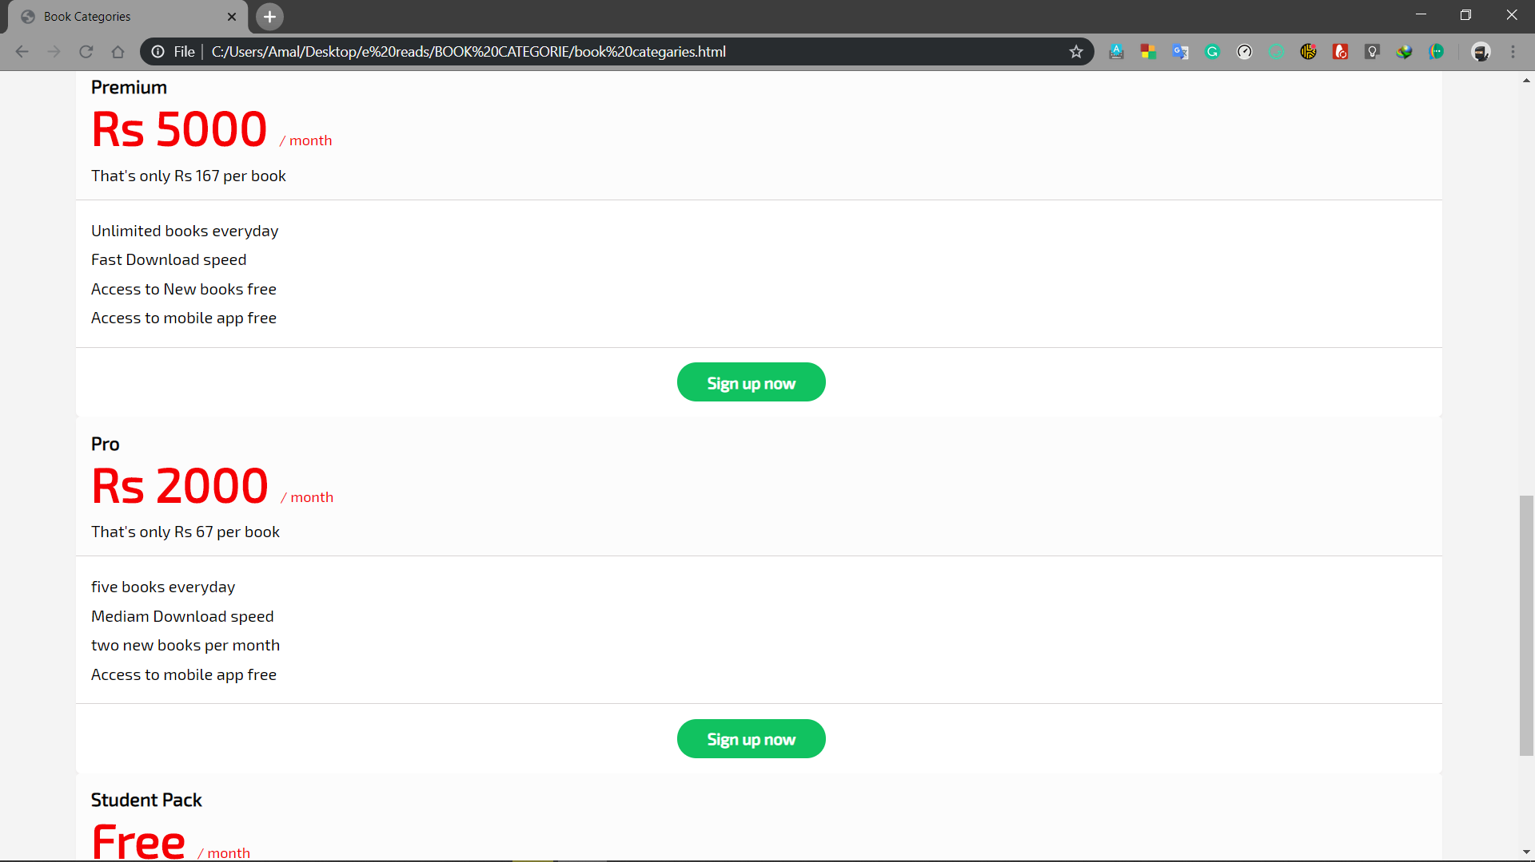

* 1. **Contact Us Page**

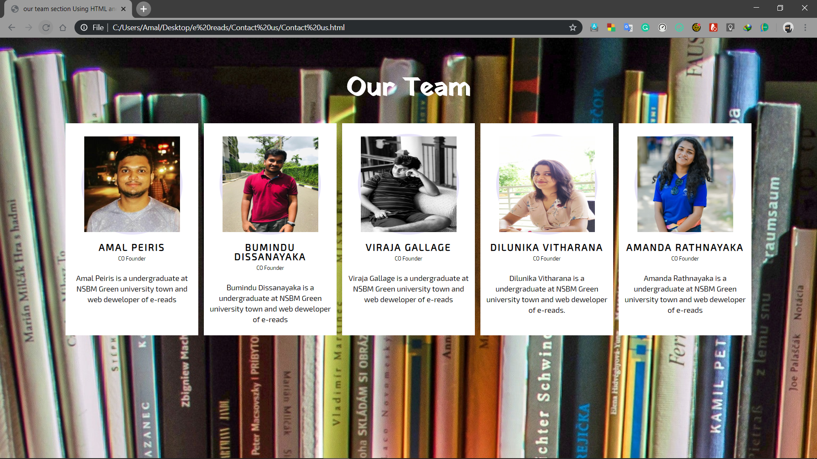

1.5 PHP Part and Database

